PERSONAL PROFILE 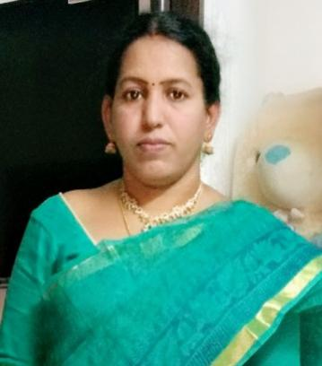
Name:Dr.T.Mamatha, M.Sc.,Ph.D;
Designation: Contract Lecturer in Home Science,
Educational Profile:

- M.Sc. (Human Development), Sri Padmavathi Mahila Viswavidyalayam, Tirupathi

Ph.D. Doctorate from Sri Padmavathi Mahila Viswavidyalayam, Tirupathi in the year May, 2008.

Ph. D PROJECT WORK ON

“Reflection of child rights in Integrated Child Development Service programme”.
- ICDS programme is the largest child development programme covering a major section of child population in the urban slums , rural and tribal areas in India. Hence, it is important to know the coverage of child rights in the training programme of the field level functionaries of ICDS.

Books published:
- “ CHILD RIGHTS ” by T.Mamatha & Dr. D.Sarada
Published by Discovery Publishing House Pvt Ltd. New Delhi.
- “CHILD RIGHTS & YOUNG LIVES” by Dr.D.Sarada & N.Rajini
(Chapter 7 contributed by T.Mamatha)
Published by Discovery Publishing House Pvt Ltd. New Delhi.

Professional Profile :
MOOCS Course: Completed the following MOOCs online courses offered by SWAYAM
1. “Early childhood care and development”-( July to October2019)
2. “Family Nutrition for Healthy Living”- (June2018 to March,2019)

SEMINARS
- Participated seven international seminars through online .
- Attended five Faculty Development Programs conducted by different universities and colleges .
- Participated thirty national seminars .
- Papers Published 04

Member in various Committees
  - ALUMNI
  - ECO-CLUB
  - Y.R.C
  - STAFF CLUB
  - CLUTURAL COMMITTEE
  - FOLLWING COMMITTEE.

